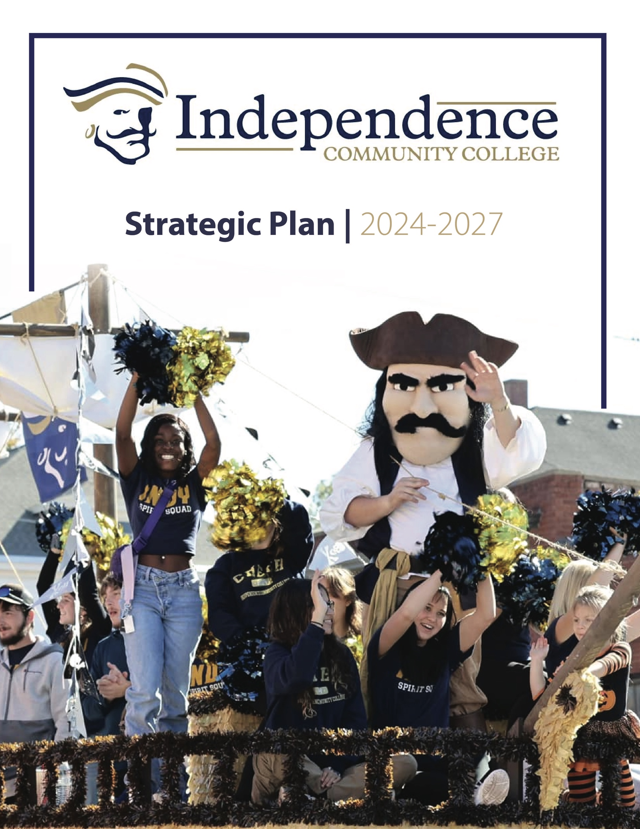

Contents
Institutional Context, Mission, and Community Values
Background ……………………..………………………………………………….………………………… 3
Mission Statement ……………………..………………………………………………………………… 3
Community Values ………………………..……………………………………………………………… 3

Imperatives for the Future
Vision for a Virtuous Cycle …………………………………………………………………………… 4
Imperative #1 – Build Capacity …………………………………………………………………… 6
Imperative #2 – Refresh Learning ……………………………………………………………… 9
Imperative #3 – Financial Stability …………………………..………………………………… 11
Imperative #4 – Community Engagement …………….…………………………………… 13
Imperative #5 – Enhanced Experiences ……………………………………………………… 15

Strategic Planning Process …………………………………………………..………………………………… 17

Operationalizing the Plan and Managing Change Over Time ……………………………… 19

Institutional Context, Mission, and Community Values
Independence Community College is a public two-year community college located in Independence, Kansas. The College was founded nearly one hundred years ago as part of the Independence public school system and now exists as a two-year educational institution accredited by the Higher Learning Commission.

Our mission is to serve the best interests of students and the community by providing academic excellence while promoting cultural enrichment and economic development.

The current campus opened in 1970 with buildings to support academics, student services, athletics, administration, and an on-campus student living community. Approximately ten years ago, the College expanded to include ICC West to support technical programs, allied health, cosmetology, and later, and other programs. There are a total of 28 programs of study and a variety of men’s and women’s athletic programs. ICC focuses on affordability and smooth transfer to institutions offering bachelor's and advanced degrees, as well as in skilled transitions to employment.

The Independence Community College learning community espouses the following core values:

Integrity:  ICC holds its employees and students accountable to be honest, ethical, and transparent. | Excellence:  ICC demonstrates continuous quality improvement in academics and services offered to students and other stakeholders. | Responsiveness: ICC looks to the future by responding to the emerging needs of its stakeholders. | Cultural Enrichment:  ICC provides an environment that values uniqueness while promoting personal growth through creativity and innovation. | Commitment:  ICC commits to making decisions that best serve its students and community.

Imperatives for the Future
Now, looking ahead, community colleges face challenges stemming from shifting demographics, evolving student needs, and a fluctuating economy and job market. Successful renewal efforts should be increasingly data-driven, focusing on student outcomes, program effectiveness, and resource allocation. Many institutions struggle to find ways to make college more affordable and to offer flexible learning options. Student needs now require robust support services such as academic advising, mental health counseling, and career planning that are crucial for student success.

Contemporary institutions must embrace innovation and agility to navigate dynamic and occasionally turbulent learning and working environments. Emerging needs place demands on curriculum enhancement to reflect industry skill gaps and student interests. Forward-thinking community colleges are charting their future by adopting new leadership approaches, engaged affiliations, and effective resource allocation. This requires institutions to collaborate and build partnerships with other institutions, businesses, and community organizations that can help to share resources and collaborate in innovative programs.

Strategy is not a grand vision, launched at the beginning of a lengthy planning period and implemented in lockstep throughout each year of the strategic plan. Instead, strategy is focused, consistent behavior practiced over time and refined by emergent elements that are incorporated into the initial, intentional strategy.

Independence Community College has recently completed a fresh round of strategic planning to address its needs and changing environment and has settled on a new vision statement supported by five Imperatives for the Future: Build Capacity – Refresh Learning – Financial Stability – Community Engagement – Enhanced Experiences.

These Imperatives are interdependent and therefore require simultaneous and focused implementation using an expeditionary mindset. As successful outcomes accumulate, they reinforce each other. As obstacles present themselves, with Imperatives in place, the College will be able to respond and to be nimble to overcome them. With success that builds over time, the five Imperatives will work together to create a virtuous cycle of improvement and engagement. A virtuous cycle is a series of events where one positive outcome leads to another, creating a continual process of improvement. Virtuous cycles are not always easy to create, but they become very beneficial and are worth the effort. Virtuous cycles create a snowball effect of positive outcomes and by understanding these dynamics, they can be intentionally promoted and sustained.

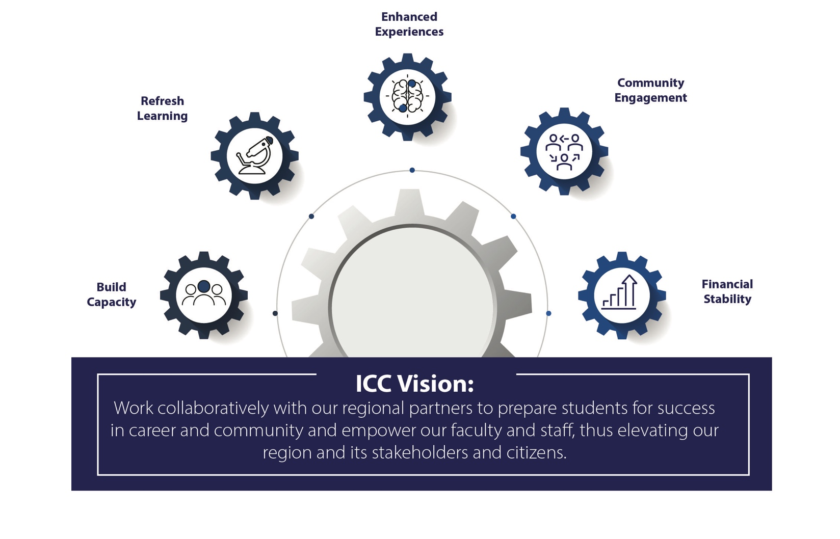

It all begins with an initial positive action or event. This initial positive event leads to a beneficial result which then reinforces, motivates, and facilitates further positive actions. As success accumulates, these additional positive actions lead to even better outcomes over time. Virtuous cycles lead to continuous improvement as the cycle of positive action and outcomes keeps repeating, creating a continuous loop of improvement.

Independence Community College envisions creating and sustaining a virtuous cycle focused on positive outcomes among the five Imperatives. The vision emerges as we:

Work collaboratively with our regional partners to prepare students for success in career and community and empower our faculty and staff, thus elevating our region and its stakeholders and citizens.

Let’s now look more closely at the details of each Imperative.
Imperative #1 – Build Capacity
What Is the Imperative? In order to best serve our communities and achieve financial sustainability, ICC needs to significantly enhance its capacity to explore, initiate, and support new endeavors and experiences.

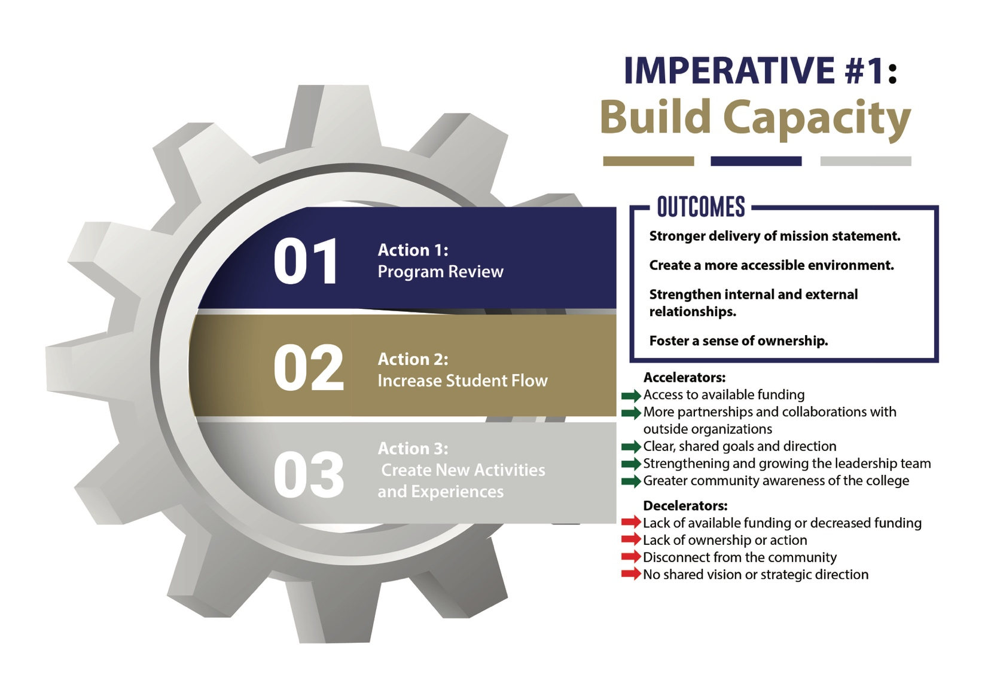

What Outcomes Do We Expect? To build capacity, ICC outcomes in building capacity include: foster a sense of ownership and action, achieve alignment towards common goals, evaluate current grants and funding sources, and collaborate with community stakeholders and public groups to build partnerships.

Strategic Action #1: Enhance use of Program Review Information of Current Offerings and Examine What We Can Do Better. Using this data, such as enrollment, program majors, and completion/placement rates to help build capacity in academic and related programs.

Strategic Action #2: Dramatically Increase Student Flow Through Knowledge Partnerships and Pipelines. Collaborate with educational partners to create more opportunities, new curricula, delivery methods, and experiences, and thus better pipelines for students. This includes: 1) enhanced articulation agreements for both incoming students from K-12, higher education, and industry partners, as well as 2) flow for students to destinations for advanced degrees, certificates, and job placement.

Strategic Action #3: Identify New Opportunities, Activities, and Experiences and Offerings, Then Proceed When Feasible. This includes new academic programs, delivery methods, new athletic programs, and workforce-oriented experiences.

Decelerators at the Imperative Level. Progress may be impeded if available funding declines or fails to meet ICC's well-defined needs. Similarly, lack of initiative, unclear actions, community apathy, or a disconnect between ICC and the community could hinder capacity building. Finally, the ability to build capacity will be decelerated if ICC lacks clear goals, priorities, or institutional will in implementing the strategic plan.

Accelerators at the Imperative Level. ICC can accelerate the building of capacity if it secures adequate funding, acquires additional grants and other revenue streams, and leverages external partnerships and collaborators. Other accelerators include achieving alignment towards common goals, solidifying the leadership team by filling open positions, and generating more community awareness about ICC.

Imperative #2 – Refresh Learning
What Is the Imperative? ICC must refresh and invigorate its learning offerings, experiences, outcomes, and the skills of its faculty and staff. This will enable ICC to serve its community and prepare its learners, faculty, and staff for success in a rapidly changing digital age.

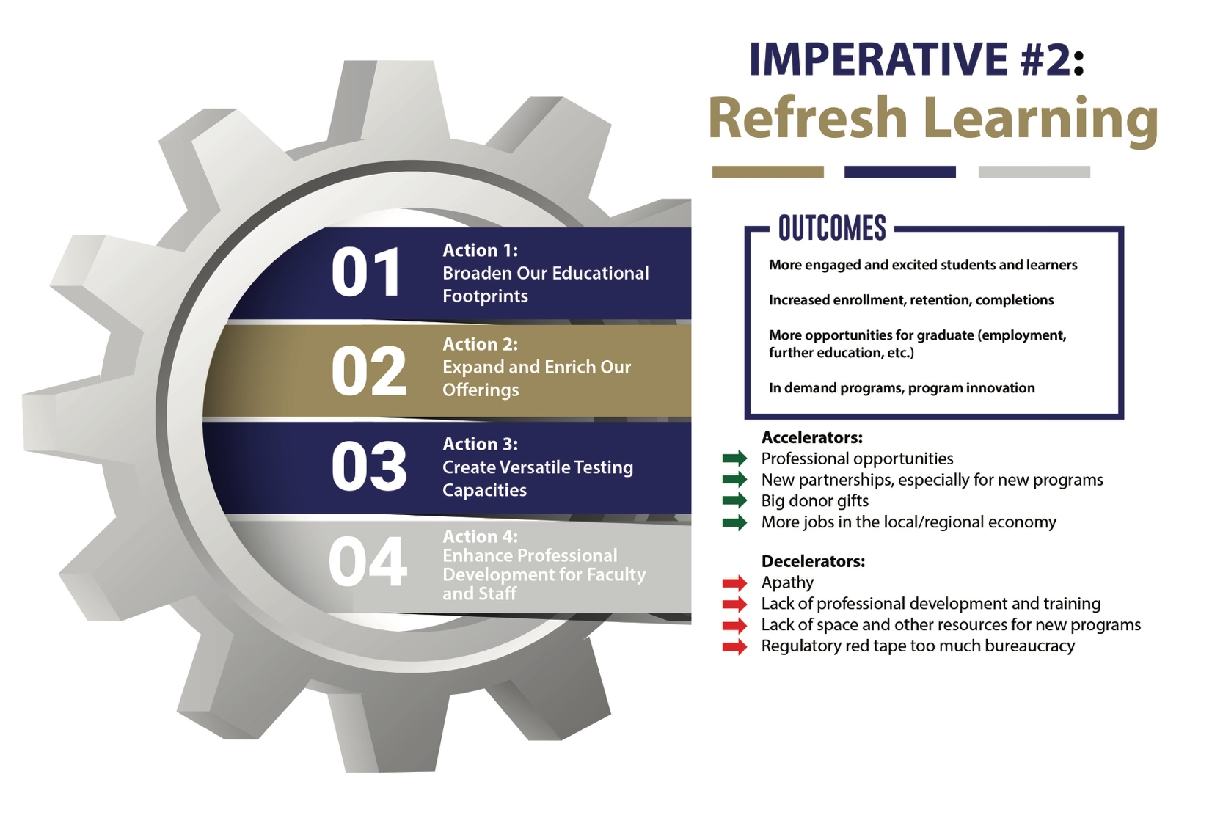

What Outcomes Do We Expect? ICC needs to understand how to better engage and excite its learners and what refreshed learning experiences and skills they will need to thrive in the emerging workforce. If it can deliver refreshed and reinvigorated learning experiences that reflect those insights, ICC will achieve: 1) more engaged and excited students and learners, 2) increased enrollment, retention,and completions, 3) more opportunities for graduates (employment, transfer qualifiers, etc.) in high-demand, innovative programs.

Strategic Action #1: Broaden Our Educational Footprint. ICC and other community colleges are uniquely positioned to be hubs of lifelong learning with a broad and dynamic curriculum due to their open access nature and commitment to local communities. ICC needs to offer curricula and learning experiences that lead adult learners forward and build community. We should also extend our delivery calendar to better encompass summer, evening, and year-round programming. By utilizing typically underused periods, we can provide additional programming and learning experiences.

Strategic Action #2: Expand and Enrich Our Offerings. Develop short-term certificates; create micro-credential programs to upskill the workforce of local industry; and add new technical programs such as HVAC, electrical, and mechanical technology. Focus on student engagement and evolving technologies to create immersive and interactive learning experiences that complement traditional classroom instruction.

Strategic Action #3: Create Versatile Testing Capacities. Create a multi-use space for practice testing and certification that lowers the anxieties around certification testing for stakeholders and increases the rates of attempts and success. Fold into this diagnostic testing capacity for learning differences. This space will also address the access gap for rural community members struggling with a multitude of unique barriers.

Strategic Action #4: Enhance Professional Development for Faculty and Staff. In order to deliver on Strategic Actions #1-#3, ICC must substantially enhance professional and talent development for faculty and staff. This will require significant internal upskilling and reskilling, a commitment to perpetual learning, and a joint commitment by institutional leadership, faculty, and staff to a culture of ongoing learning.

Decelerators at the Imperative Level: Excessive regulatory obstacles and bureaucratic processes may hinder the advancement of this imperative. Limitations of space, staff, and fresh skill sets would delay implementation. A potential decelerator would be difficulty in mobilizing the commitment of faculty and staff to reinvent their skills to face these new challenges. Success will require active engagement of the college community to build personal and group commitment and agency.

Accelerators at the Imperative Level: This Imperative will be accelerated by ICC working with local, regional and more distant employers to identify, train, and retrain in skills for the emerging new economy. Support and investments by community organizations, employers, state agencies, and other groups interested in workforce transformation would accelerate these projects if ICC can demonstrate vision and the capacity to deliver.
Imperative #3: Financial Sustainability
What Is the Imperative? To maintain financial stability moving forward, ICC will need to reinvigorate programs, experiences, and partnerships; to expand its service area; and to nurture fresh revenue streams and refined business models.

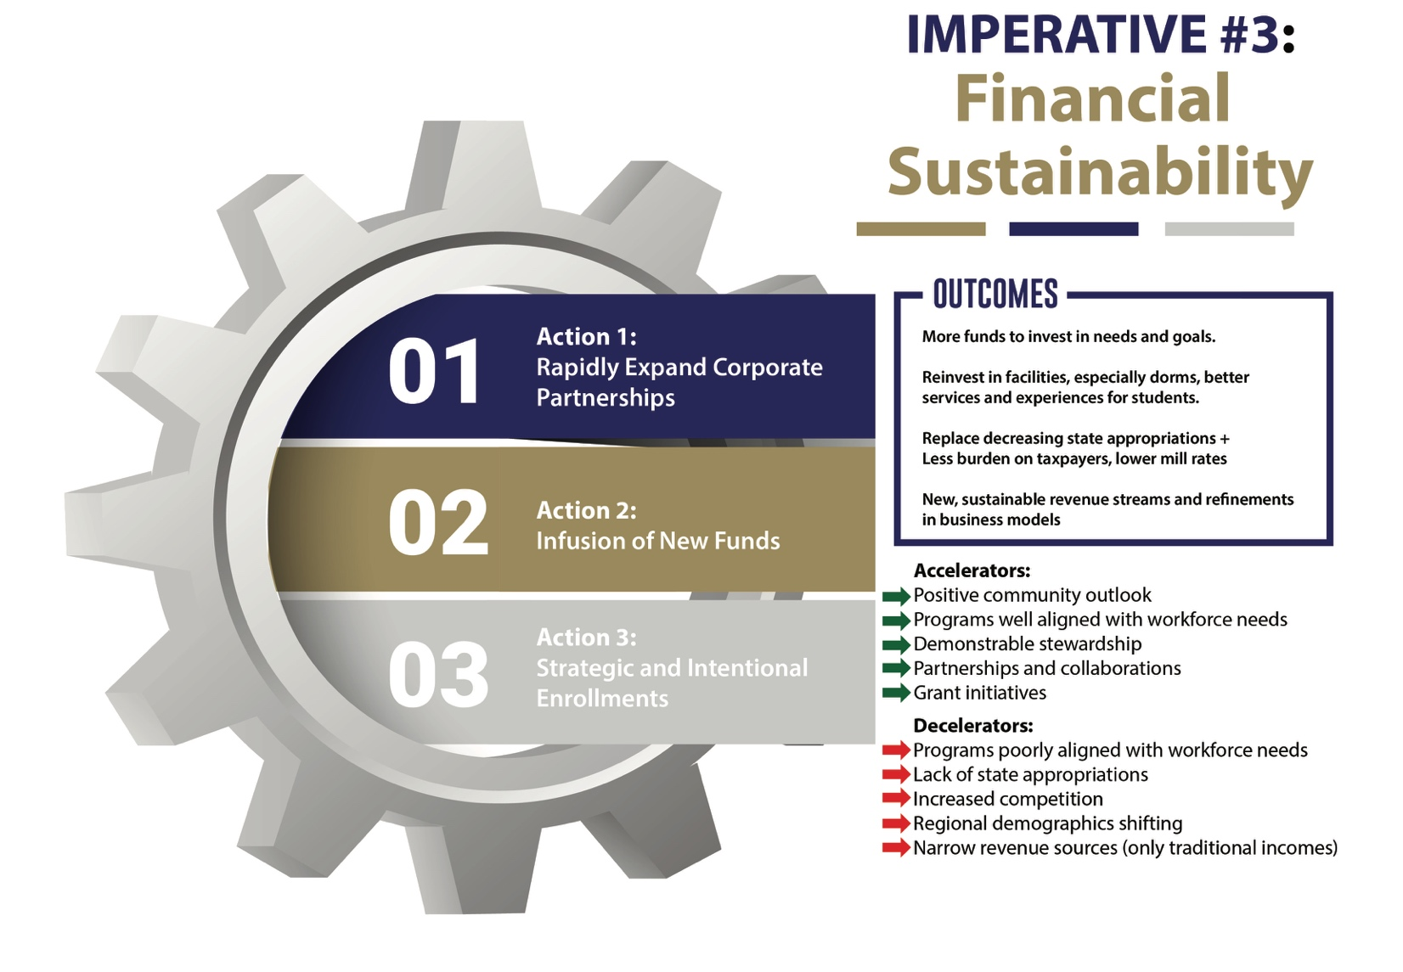

What Outcomes Do We Expect? ICC expects to generate more funds for investment in our needs and aspirations. Fresh funding from new sources will reduce our dependence on state appropriations which have been declining, and will place a smaller burden on taxpayers. New sustainable revenue streams and refinements in our business models are key to achieving these outcomes. New funding would support reinvestment in facilities, such as better student housing and better services and experiences for students (Imperative #5).

Strategic Action #1: Rapidly Expand Corporate Partnerships for New Revenue Streams. Specifically, ICC must partner with local employers and the ICC Foundation to secure funding for training programs based on immediate employer needs. This is a key foundational element that must be addressed within the first year of the plan. This strategic action should mirror the steps and timeline from Imperative #2, Action 2 (Refresh and Expand Offerings).

Strategic Action #2: Advance the Institution with an Infusion of New Funds. This Strategic Action will require ICC to expand development, philanthropy, and sponsorship/grants activities and to connect with overlooked individuals and groups. ICC should look to sponsors and opportunities outside its region and identify external funding to support additional advancement resources.

Strategic Action #3: Manage Enrollments Strategically and with Intentionality. ICC should develop a Strategic Enrollment Management (SEM) Function and enhance both the use of analytics and this initiative’s connection to other strategic functions within the institution. ICC should also develop a Program Innovation Function, which will be critical to Imperative #2: Refreshed Learning and to Imperative #5: Enhance Experiences. The recently hired Director of Enrollment and Retention will be responsible for achieving specific, measurable short-term and long-term targets for enrollment and net tuition revenue in collaboration with the ICC leadership team.

Decelerators: Our current programs are not fully aligned with emerging workforce needs and our current revenue streams are narrow and traditional. If these conditions are not materially improved, efforts to achieve financial sustainability will likely fail. Furthermore, our regional demographics are unfavorable in both the short and long term. ICC must overcome this decelerator by reaching out to new markets and broader service areas, and in utilizing expanded partnerships, collaborations, and offerings.

Accelerators: When ICC is successful in enhancing community engagement (Imperative #4), it will accelerate achieving financial sustainability (Imperative #3). A virtuous cycle of actions and innovations. Also, achieving better alignment with serving workforce needs, expanded partnerships, and collaborations will all accelerate our quest for financial sustainability.

Imperative #4 – Community Engagement
What Is the Imperative? To continue to achieve its vision of serving the best interests of students and the community, ICC must broaden and deepen its engagement with its local and regional community.

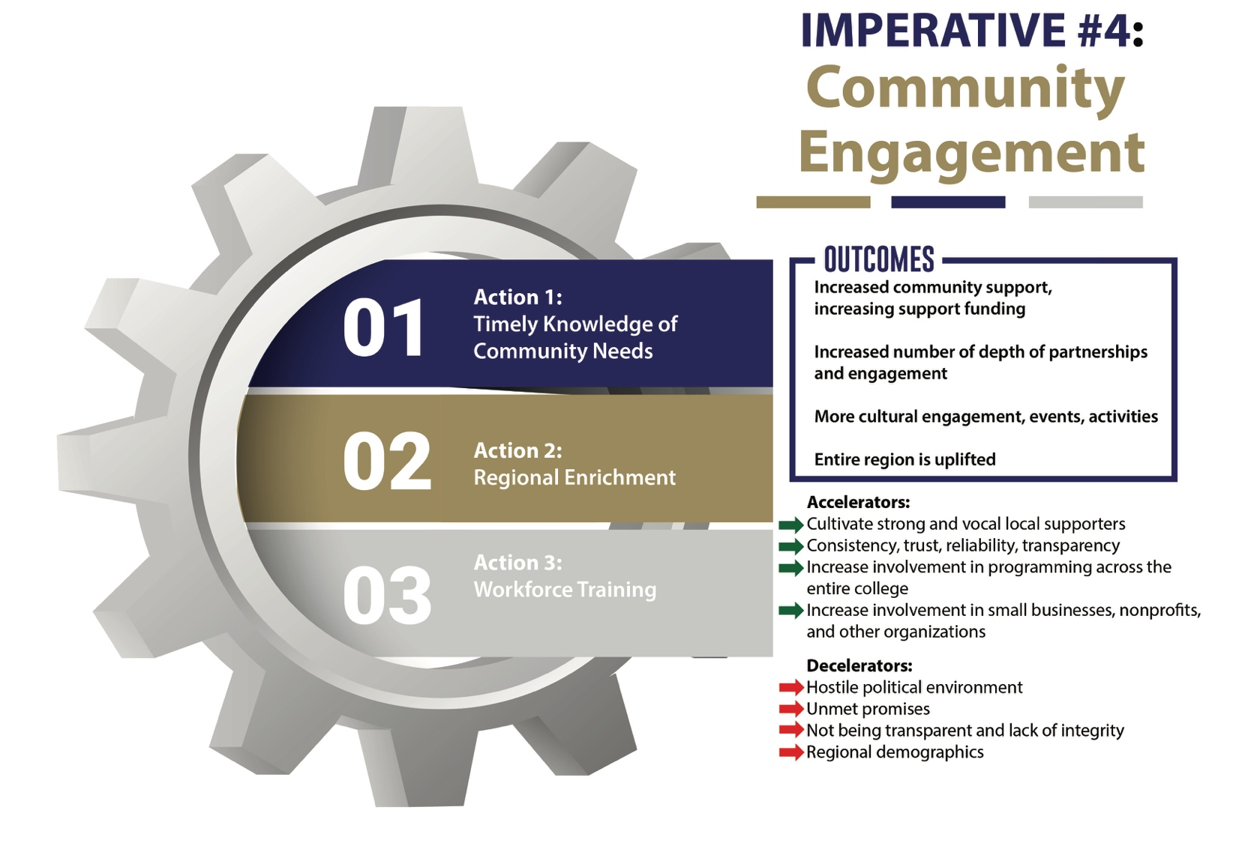

What Outcomes Do We Expect? If ICC is successful in engaging its community and revitalizing the region, its efforts will attract more people to join us, send students to us, and support the use of taxes to educate local students. This work will increase the number and depth of partnerships and engagement, and it will enable the creation of more cultural engagement, events, and activities. As a result, the outcome will be an entire region uplifted.

Strategic Action #1: Timely Knowledge of Community Needs. Collaborate with key local industries to identify their needs and develop curricular solutions aligned with our expertise. Develop continuing education courses for professional fields (teaching, trades) in the region that require ongoing professional development, certification, licensure, and continual upskilling. Meet employers' needs by developing prepared employees and by continuing their development after employment.

Strategic Action #2: Regional Enrichment. Identify, develop, and deliver innovative events, programs, and experiences that showcase the institution's distinctive strengths and set it apart from others in the region. These activities should be targeted to elevate culture, create goodwill, and generate new revenue.

Strategic Action #3: Workforce Training. Foster economic development and revitalization within our region through innovative programs, workforce training initiatives, and partnerships with local businesses and organizations.

Decelerators at the Imperative Level: In the past, community engagement has been hindered by an unsupportive political climate and by ICC’s limited exploration of the potential opportunities for
engagement. ICC also had a track record of falling short of our promise and potential. We need to do better. Finally, progress in community engagement could be slowed if we are perceived as lacking transparency, failing to integrate within the local community, or not being a genuine partner with community members.

Accelerators at the Imperative Level: Nurturing strong community engagement will be accelerated by cultivating committed and vocal local supporters. ICC needs to establish consistency, trust, reliability, and transparency in its community interactions. We can also accelerate community engagement by increasing involvement in academic and cultural programming by reaching out to small businesses, nonprofits, and other community organizations.
Imperative #5 – Enhanced Experiences
What Is the Imperative? Enhancing existing experiences and creating new ones in response to evolving needs and opportunities is a key element in achieving all five strategic imperatives.

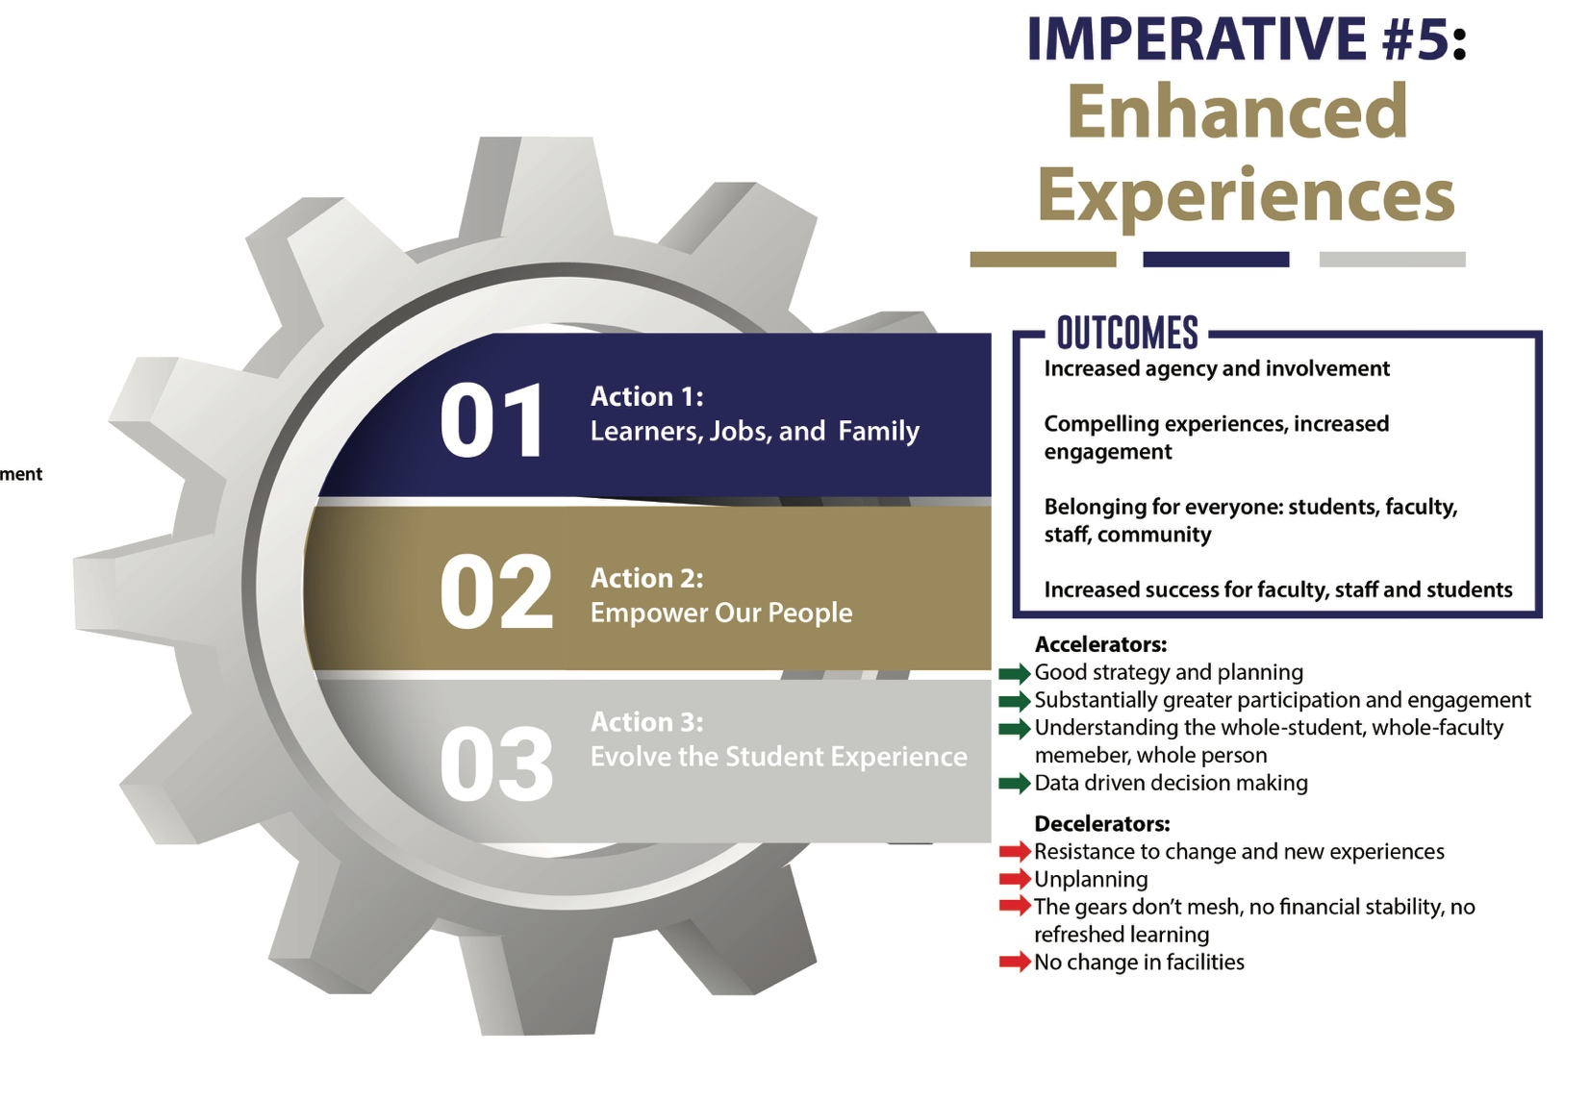

What Outcomes Do We Expect? ICC expects that enhancing experiences of learners, faculty, and staff will increase agency, involvement, and commitment. However, this outcome gets sticky, since the more they get, the more they will want; we will need to continue to redouble our efforts, prioritize our efforts, and manage our resources. Enhancing experiences will increase the sense of belonging for everyone– students, faculty, staff, and community. This Imperative will increase success for faculty, staff, and students.

Strategic Action #1: Learners, Jobs, and Family for the Common Good. 1) Engage younger students and K-12 teachers to ensure they understand the opportunities at ICC and easily see themselves in college; 2) Create immersive dual enrollment programs as a springboard to 4 year and graduate degrees that benefit learners, their families, and the community; 3) Become a destination of choice by highlighting the cultural and intellectual richness of our community and broadening our ideas about the changing world around us; 4) Serve as a focal point of access for students, employees, and community members.

Strategic Action #2: Empower Our People. Assist faculty and staff in recognizing and promoting innovative initiatives that align with the needs of regional businesses, government, non-profits, and schools, as well as creative endeavors that contribute to the cultural enrichment of our communities.

Strategic Action #3: Evolve the Student Experience. As we empower our employees to align their expertise with regional needs, we must simultaneously invest equal effort in ensuring that the student experience remains a top priority: 1) Begin a long-term effort to better understand the needs, hopes, and dreams of our students using a suite of user-experience tools and data-informed applications; 2) Ensure that all campus spaces are attractive, safe, and designed to energize and engage; 3) Develop strategies to improve student health and safety.

Decelerators at the Imperative Level: To achieve this imperative, ICC must overcome latent resistance to change and new experiences often expressed as “unplanning” by those who attempt to cling or revert to old practices. Other decelerators to enhancing experiences would include if the gears of the five strategic imperatives don't mesh, aren’t realized, or any Imperative is abandoned.

Accelerators at the Imperative Level: Achieving this imperative can be accelerated by good strategy and planning and substantially greater participation and engagement. Moreover, understanding and incorporating the whole-student, whole-faculty member, whole-person philosophy is critical, as is data-driven decision making.

Strategic Planning Process
The ICC planning and executive teams worked collaboratively with supporting consultants to craft strategy using a design approach over four stages of Design, Divergence, Convergence, and Alignment. These stages occurred over 12 collaborative, virtual sessions along with a number of between-session synthesis and writing activities to produce this strategic plan.

During the initial design of a strategy crafting process, intentional effort ensured that the entire process was designed to meet expectations and take the appropriate amount of time, resources, and engagement. Tools were selected to address important questions and deliver the necessary outcomes.

Divergence employed a variety of creativity and innovation methods to generate a large number of choices. The paired processes of divergence and convergence helped participants explore opportunities, create choices, and filter through the possibilities to craft the best strategies for the future.

Convergence had the primary goal of making choices from the large variety of possible opportunities created during divergence. Here filtering, selecting, and testing ideas was critical. Early concepts of the strategies began to form.

Driven by cooperation and communication, in the final alignment stage the strategies and their corresponding documents were produced and carefully aligned with the resources and capacities available to successfully execute.

The process included the following individuals from two committees as well as two open community sessions to gather input broadly from the community.

Strategic Planning Committee Members | Executive Team Members
Melissa Anderson  Director of Athletics  Chelsea Bailey  Cosmetology Instructor  Benny Beurskens  Director of Maintenance  Anita Chappuie  Director of Institutional Research  Kris Ferguson  Chief Marketing Officer  Andrew Gutschenritter  Controller  Matt Kittrell  Sr. Director of Industry and Employer Engagement  Malinda McGowan  Associate Professor of Sociology  Paul Molnar  Professor of Theatre  Heather Mydosh  Professor of English  President, Faculty Senate  Allen Shockley  Professor of Mathematics  Cody Westerhold  Director of Student Life | Jonathan Sadhoo  Interim President and  VP for Administration & Finance  Lori Boots  VP for Human Resources  Taylor Crawshaw  VP of Academic Affairs  David Adams  VP of Student Life  Kris Ferguson  Chief Marketing Officer

Operationalizing the Plan and Managing Change Over Time
Implementing significant institutional change takes both focus and persistence, but the task can be made easier if new and emerging strategies can be normalized as part of regular and recurring efforts. Rather than create separate and parallel structures, budgets, and processes for the new ideas and actions contained in this plan, it is advantageous to integrate them into continuous planning and execution.

Once the strategic plan (and accompanying action plan) have been finalized, endorsed, and published, two key efforts are recommended. The first is to identify the top priority actions, and to work on sequencing these and the actions that follow. Strategic actions require resources, both in the time of individuals, teams, and offices that organize and act on them, and also in terms of the costs and funds that should be allocated and reserved to support the actions. By integrating these new strategic actions into annual institutional plans and budgets each year, new efforts can be placed alongside recurring actions and activities.

In addition, many of the ideas contained in this strategic plan require fresh approaches, revisions, and innovative processes to create new activities, put them into practice, and generate value in the outcomes they produce. This is the basic process of innovation. Developing skills and using tools to enhance innovation can be helpful throughout the implementation process and support for doing that work is crucial

It is often prudent to establish a network of point persons, accountability checks and balances, and team assignments and coordination when new activities are implemented. Central coordination by a planning professional and the executive team are helpful. Regular meetings to coordinate strategic planning activities, assign and manage resources, and track outcomes are the key areas of focus for executive coordination.

Managing change is a more significant and challenging task than implementing a strategic plan, as it considers all of the dynamics of change– the old and the new– and the competing priorities and choices that the institution must consider. Adhering to a clear vision to create a virtuous cycle will elevate the institution and the region, and by tending to the implementation details of the five Imperatives, institutional leaders leverage change in the context of strategy balanced with urgent operational needs.

There are a number of tools and processes that can further success in strategy. The creation, collection, and analysis of institutional Key Performance Indicators and related metrics give the institution insight and evidence for directed change toward specific goals and outcomes. These would be enhanced with Key Strategic Indicators that are tied very specifically to the five Imperatives and their outcomes.

Additionally, both quarterly course corrections and annual plan updates would keep the plan fresh through the three-year planning horizon. Course corrections are adjustments made to a plan or direction in order to achieve an outcome more effectively. The need for course corrections arise due to changing circumstances when the environment, market, or competition might shift, making the original plan less effective. Course corrections are a combination of evaluation of progress and outcomes, analysis of gaps and potential options, and fresh decisions that may involve changing tactics, allocating resources differently, or even revising overall Imperatives or Strategic Actions. Annual updates are less frequent yet perhaps more substantial changes to the planning document.

